Car Pool

Report 1: July 27, 2008



By: Team B – Arlo, Ben, James, Jordan, Parul, Sam

Introduction

Car Pool is an online system being developed to encourage and manage car pooling in New Zealand. Users register for the service and will use existing Open ID compliant user accounts for this purpose. Users will be able to request rides, offer rides and accept offer or requests for rides. When an offer is made or accepted the ride is added as an event to the user’s Google Calendar. This calendar can then send the user automated emails regarding updates on their ride. Each user has a social score which is helpful for drivers and riders to identify who contributes to the car pooling community and find out if someone is good or bad rider or driver.

Project Methodology Outline

For our project we have decided to combine the principles of the Agile methodology with the process framework of Rational Unified Process (RUP). The RUP process framework will be applied to each of the three iterations we have to produce, the first, second, and final prototype, as defined by our customers (the lecturers). A single iteration is expected to result in a working part of the system being built and multiple iterations (in our case three) are expected to result in the fully integrated complete product.

RUP has the following four phases: inception, elaboration, construction and transition. Inception and Elaboration involve identifying the various actors with which the system will interact and defining the nature of this interaction. Furthermore use cases are developed and a risk assessment, and project plan with milestones and resources to be used developed. We will do all this through our design documentation, project plan and Risk Mitigation Monitoring and Management (RMMM) plan. These will be ‘live’ documents that are expected to evolve and change over the course of various iterations. The construction phase involves the actual building of the components along with integration and testing. And finally the transition stage involves ironing out any tiny problems and putting in features that were postponed. As stated before all iterations will have all four of these phases.

RUP recommends modeling visually which is why UML will be used to create the design documentation. The modeling will be done in a Just In Time (JIT) basis as prescribed by Agile methodologies. This means that the scope of the model will be restricted to what is required from that particular iteration. Agile methodologies prescribe avoiding Big Design Upfront (BDUF) because requirements are expected to change over the course of the project anyway! The same principle will be applied to our project plan. Like the requirements the plan will be created for a particular iteration at the beginning of that iteration. This plan will be reassessed throughout the iteration to keep track of progress. Agile methodology also prescribes addressing priority features at a time which is why at the beginning of the project a scope will be identified for each of the three iterations which will define what features will be developed when. Finally it is recommended that standard routinies be automated and we intend to do this through ANT scripts.

Project Plan

Following the principles above a Gantt chart was developed as follows:

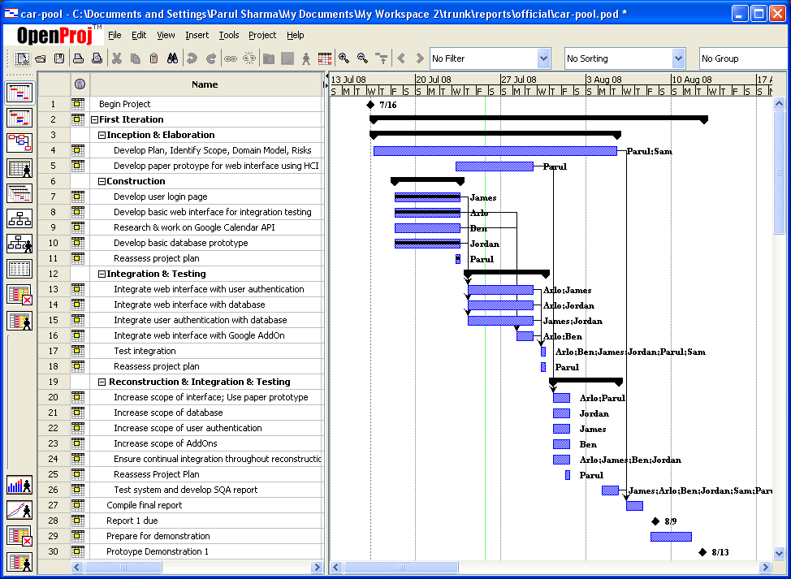

And also the project scope helped specify what needs to be functional for the first prototype:

SCOPE FOR PROTOTYPE ONE
Users can register for system using OpenID accounts.
Users can log into system successfully
Users can add an offer for a one-off ride, specify location from and to, make additional detailed comments and specify the date and time.
This date and time gets added to user’s Google Calendar if they have one.
Users can search for rides, and accepts them.
Again the date and time gets added to user’s Google Calendar
The database of users and locations can communicate with the web
interface.

The aim of the first prototype is to: achieve successful integration of calendar, database and user login with the website.

SCOPE FOR PROTOTYPE TWO
Users can offer or request regularly scheduled rides, specify ‘via’ which locations they are traveling, specify number of seats (which system can appropriately reduce), specify return or one way ride, have Google Map integrated with locations,.
User can talk to Driver via comments section before accepting a ride and specify how many seats they will be using.
Users can accept a requested ride or counter offer (see use cases)
Users can withdraw or edit details
Users are rated
The website follows good HCI principles.

